ICMR/ PR UNIT/IIFO/2019/41

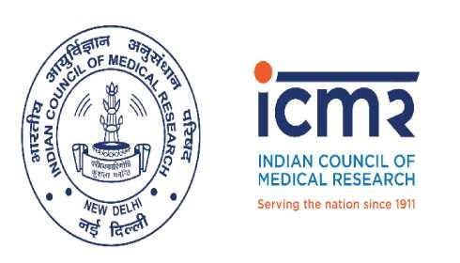

INDIAN COUNCIL OF MEDICAL RESEARCH
Department of Health Research – Ministry of Health & Family Welfare
Government of India
Press Release
Release of India State-Level Malnutrition Paper
18th September 2019, New Delhi
The India State-Level Disease Burden Initiative is a joint initiative of the Indian Council of Medical Research, Public Health Foundation of India, and Institute for Health Metrics and Evaluation in collaboration with the Ministry of Health and Family Welfare, Government of India, along with experts and stakeholders associated with over 100 Indian institutions, involving many leading health scientists and policy makers from India. This scientific paper involved a large number of collaborators, including many leading malnutrition experts from India.
The malnutrition trends over about three decades reported in this paper utilized all available data sources from India, which enable more robust estimates than the estimates based on single sources that may have more biases. The state-specific findings described in this scientific paper highlight the extent of the effort needed in each state to achieve the national and global targets for various malnutrition indicators.
On the release of these findings, Prof. Vinod K. Paul, Member NITI Aayog said, “The study findings are released at an opportune time when Government of India is intensifying its efforts to address the issue of malnutrition across the country. September is being observed as Poshan Maah with the aim of reaching every household with the message of nutrition. The trends reported in this scientific paper for every State indicate the efforts needed in each State to control malnutrition. State governments are being encouraged to intensify efforts to reduce malnutrition and undertake robust monitoring to track the progress. Focus on improving the overall nutritional status of girls and women during the preconception and pregnancy period, providing quality antenatal care will positively influence low birth weight indicators and extend the benefits to next generation.”

Prof. Balram Bhargava, Secretary to the Government of India, Department of Health Research, Ministry of Health & Family Welfare, and Director General, ICMR said, “In our commitment to the Poshan Abhiyaan, we are taking important steps to augment monitoring of malnutrition indicators across the country. The National Institute of Nutrition, an ICMR institute, and other partners are setting in place mechanisms to ensure that there are more data available on malnutrition in the various states of India which will help monitor progress. The findings reported in the paper published today highlight that there are wide variations in the malnutrition status between the states. It is important therefore to plan the reduction in malnutrition in a manner that is suitable for the trends and context of each state.”
Prof. Lalit Dandona, Director of the India State-Level Disease Burden Initiative and senior author of the paper said, “Inclusion of data from all available sources in India over three decades has enabled robust estimation of malnutrition trends for every state in this study, which is a useful reference for further efforts to improve nutritional status across India. This study reports that malnutrition has reduced in India, but continues to be the predominant underlying risk factor for child deaths, underscoring its importance in addressing child mortality. It reveals that while it is important to address the gaps in all malnutrition indicators, low birth weight needs particular policy attention in India as it is the biggest contributor to child death among all malnutrition indications and its rate of decline is among the lowest. Another important revelation is that overweight among a subset of children is becoming a significant public health problem as it is increasing rapidly across all states of India.”

Dr. Henk Bekedam, WHO Representative to India said, “Malnutrition in children is an outcome of inadequate maternal nutrition, poor sanitation and hygiene and suboptimal infant feeding practices. Improvement in nutrition, therefore, is linked not only with food availability and access, but also with food safety and environment. The Prime Minister’s vision of Swachh Bharat together with the Poshan Abhiyaan will play a critical role in reducing malnutrition and helping the country to achieve the 2030 nutrition goals.”

Dr. R. Hemalatha, Director, National Institute of Nutrition, ICMR said, “NIN will continue to play an integral role in unifying the diverse nutritional goals of the country and providing solutions in the changing dietary landscape due to changes in food patterns, effect of climate change on agricultural patterns and changing lifestyles of the Indian population. We need intensive monitoring of the malnutrition indicators as well as mass awareness programmes at the community-level to increase the diversity of food items consumption.”

