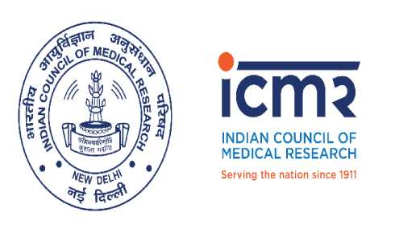

**INDIAN COUNCIL OF MEDICAL RESEARCH**

Department of Health Research – Ministry Health & Family Welfare

Government of India

**Press Release**

**ICMR-RMRC Gorakhpur organizes "Two day workshop on Biomedical Communication"**

**14th February 2019, Gorakhpur**

ICMR-Regional Medical Research Center (RMRC), Gorakhpur organized a workshop on Biomedical communication for scientists and officers of the institute including medical professionals of BRD Medical College.

The workshop was inaugurated by Professor Ganesh Kumar, Principal BRD Medical College; as the chief guest at the occasion. The other guests present on the occasion were Dr Pushkar Anand (Additional Director Health), Dr. Ganesh Yadav (Joint Director Health), Dr. Sagar Ghodekar (Surveillance Medical Officer, WHO India) and Dr. Arvind Pandey (District Malaria Officer). Dr Kamran Zaman (Officer In Charge, ICMR-RMRC, Gorakhpur) welcomed the guests and participants from Headquarters, BRD Medical College, State Health Department.

Speaking on the occasion Prof. Ganesh Kumar said that there is scope for research activities to be carried out by BRD Medical College in collaboration with ICMR-RMRC Gorakhpur and emphasized on training the medical residents for research methodology and planning research studies.

Dr. Rajni Kant Head, Research Management, Policy, Planning and coordination ICMR Headquarters gave a background of the importance of media training for health professionnels nowadays and the role of media for publicity of various health issues.

The two day workshop was divided into various sessions. The first day sessions were devoted to basics of Media interaction, working with media; including case studies. The media training was imparted by Communication unit scientists, PRO IMCR and Global Health strategies.

The second day of the workshop focussed on lectures on writing research papers and policy brief by Dr R C Sharma (Former Director -In-Charge, ICMR-DMRC, Jodhpur), Dr Sanghamitra Pati (Director, ICMR-RMRC, Bhubaneswar) and Dr P L Joshi (Former Director NVBDCP & Chairman of Joint SAC for RMRCs) and Dr Rajni Kant.

Momentos and certificates were presented to the speakers and participants on the complétion of the workshop.

Dignitaries from ICMR headquarters, State Heath department Gorakhpur UP and staff of RMRC institute were also present on the occasion.

Dr Kamran Zaman

Scientist - C & Officer-In-Charge

ICMR-RMRC, Gorakhpur

BRD Medical College, Gorakhpur

Email Id- drkamran.niv@gmail.com

Phone: 0551-2506698

eom